Big Data And Hadoop
Assignment 1 of Session 8
Problem Statement:
Write a word count program to implement word count using Pig.

Solution
Input -
Input File in already placed in hdfs which is as follows:
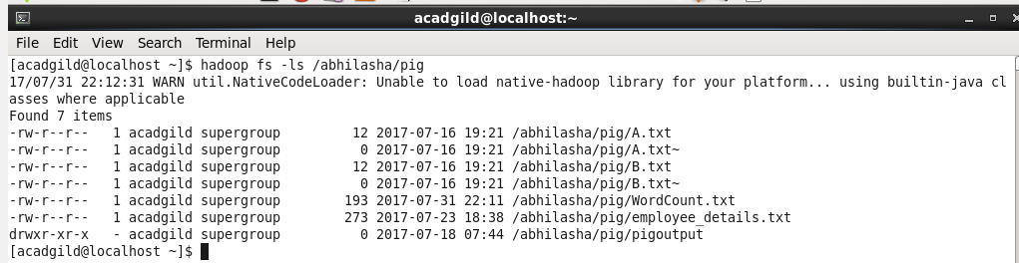

Content of the file is:
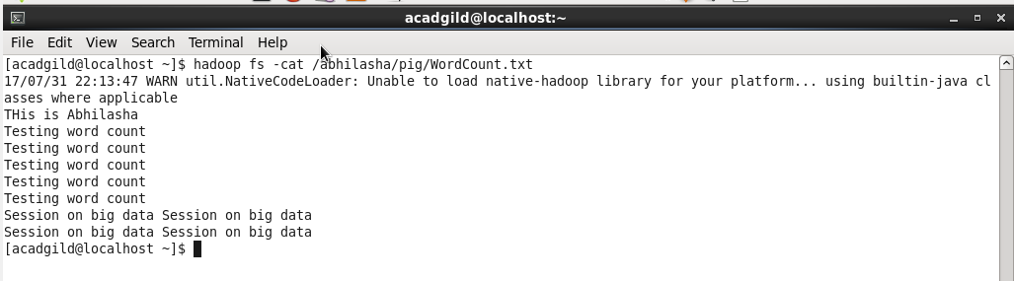

Mode of Execution-
Using mapreduce mode of execution. Starting pig shell in mapreduce mode as follows:
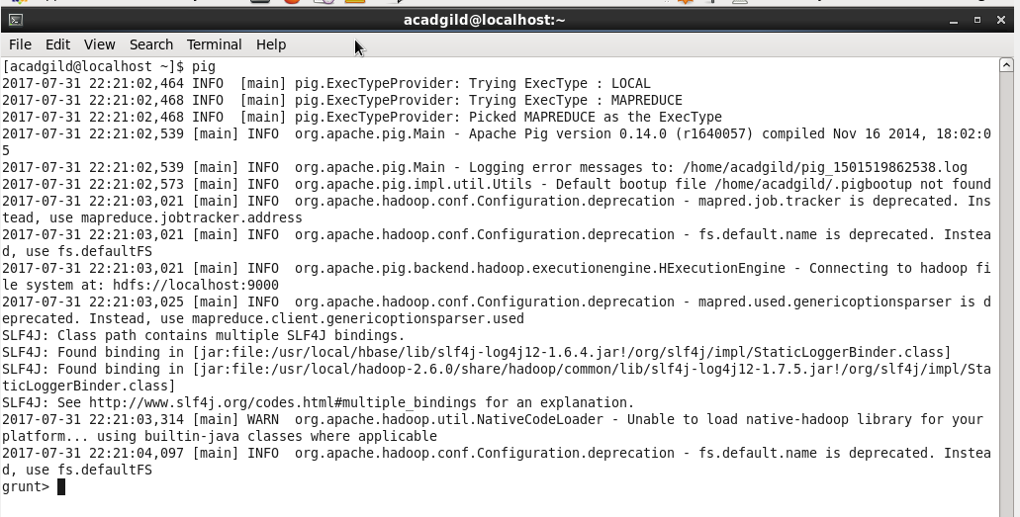

Execution-
Step 1: Load the input file /abhilasha/pig/WordCount.txt as follows
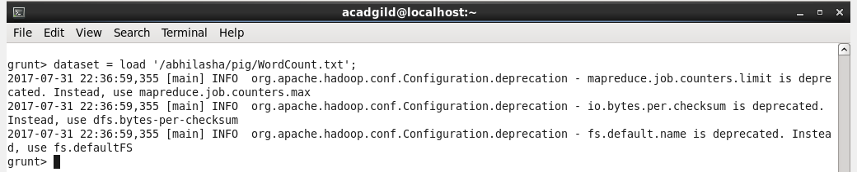
This command is used to load the dataset.

Step 2: dump dataset;
This command is used to display the contents on the console
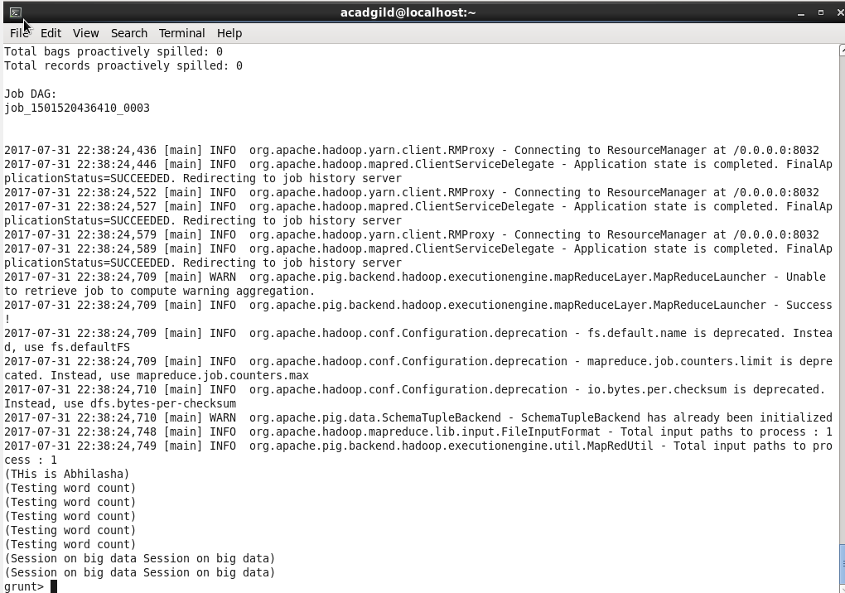

Step 3: Check the definition of dataset using describe.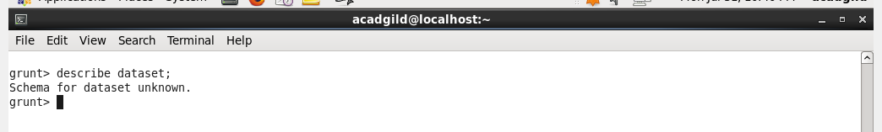
This dataset has no schema defined and hence, the output.

Step 4: In this step we use TOKENIZE which is used to split every line into words.
Output of tokenize is a bag of words in a line. We have then used FLATTEN to remove the bags structure and take all the tuples out of the bag.
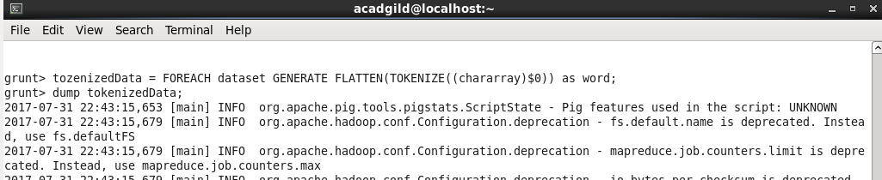

On dumping tokenizedData we get the following
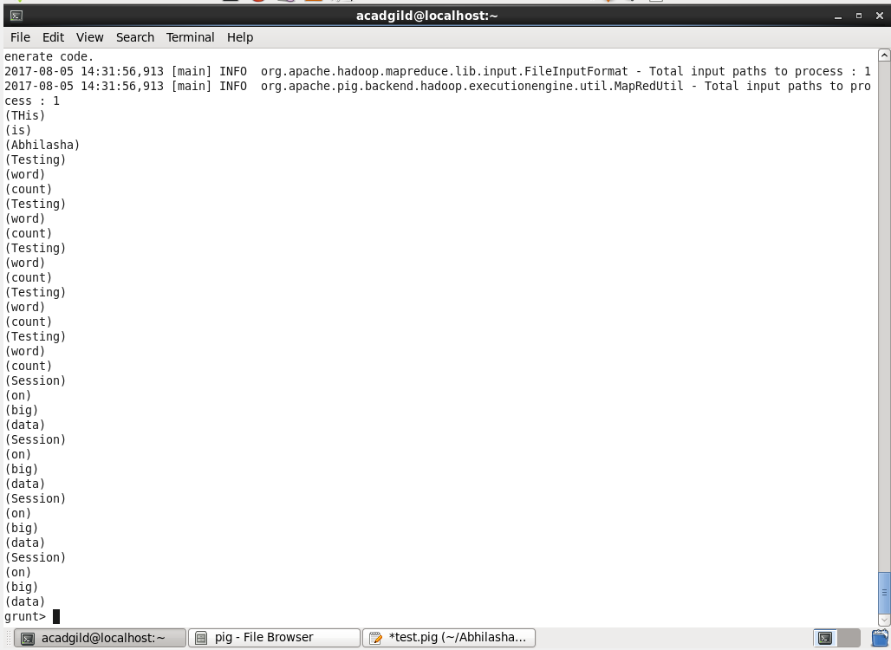

Step 5: We now group the words.
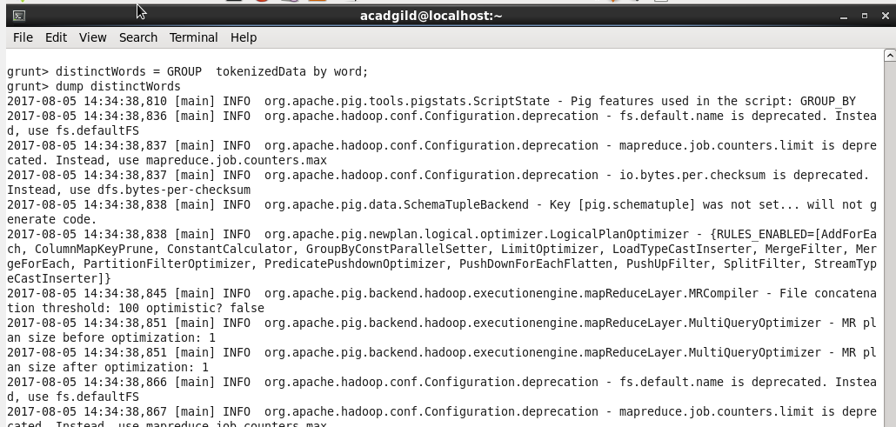

Step 6: On dumping distinctWords, we get the result as follows :

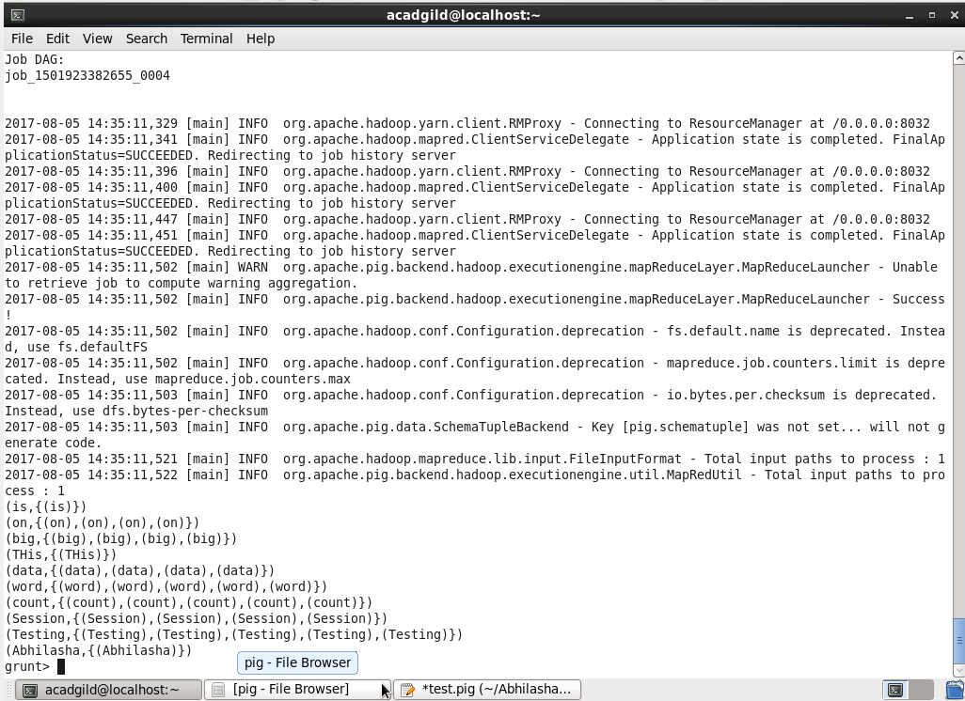

Also, the definition of distinctWords is as follows:
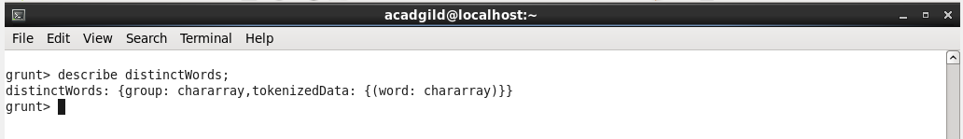

Step 7: Now, we generate count for each word.
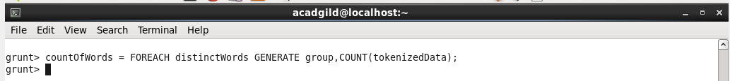

Step 8: On describing distinctWords, we get as follows:

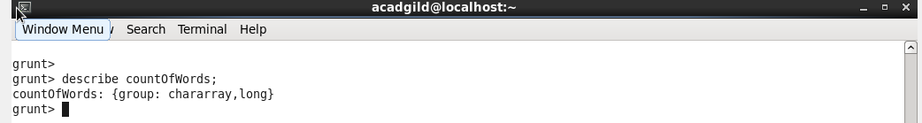
Step 9: Final output is as follows :
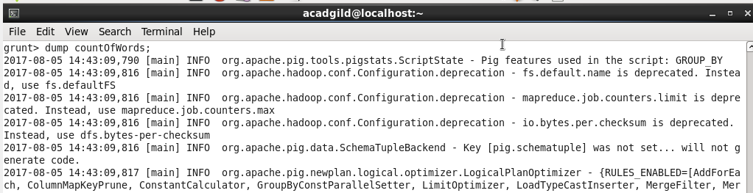

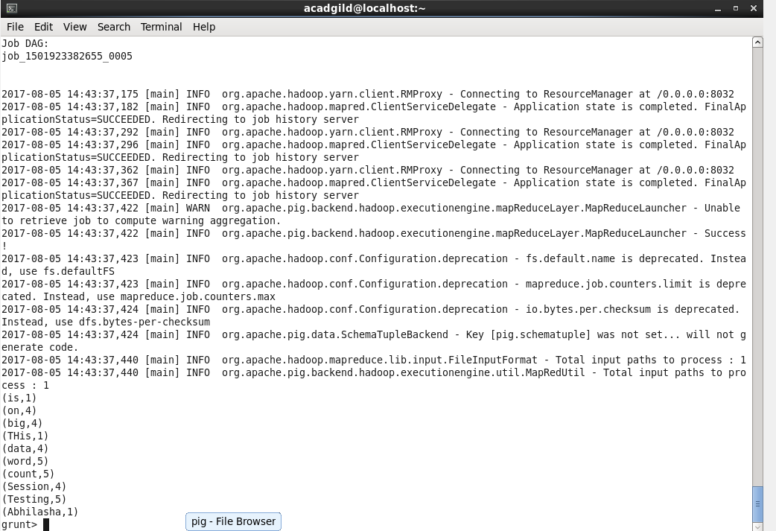

Running wordCount in a script
We can run the above statements in a script all together as follows :
Script is placed at the location mentioned below
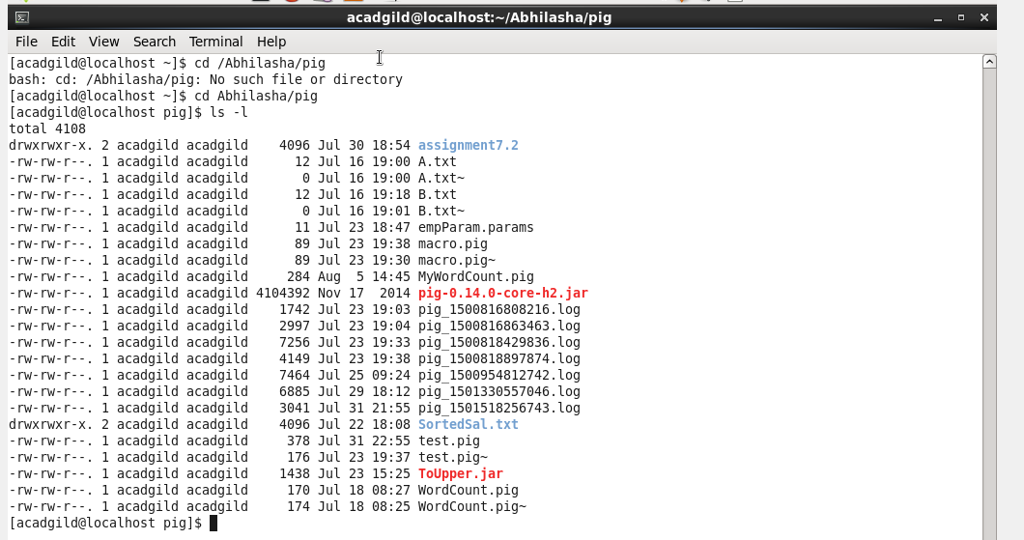

We execute the script as follows:
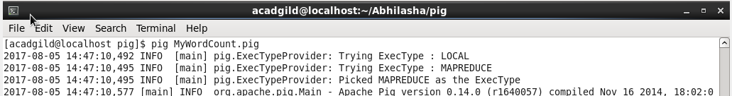

The output is as follows:
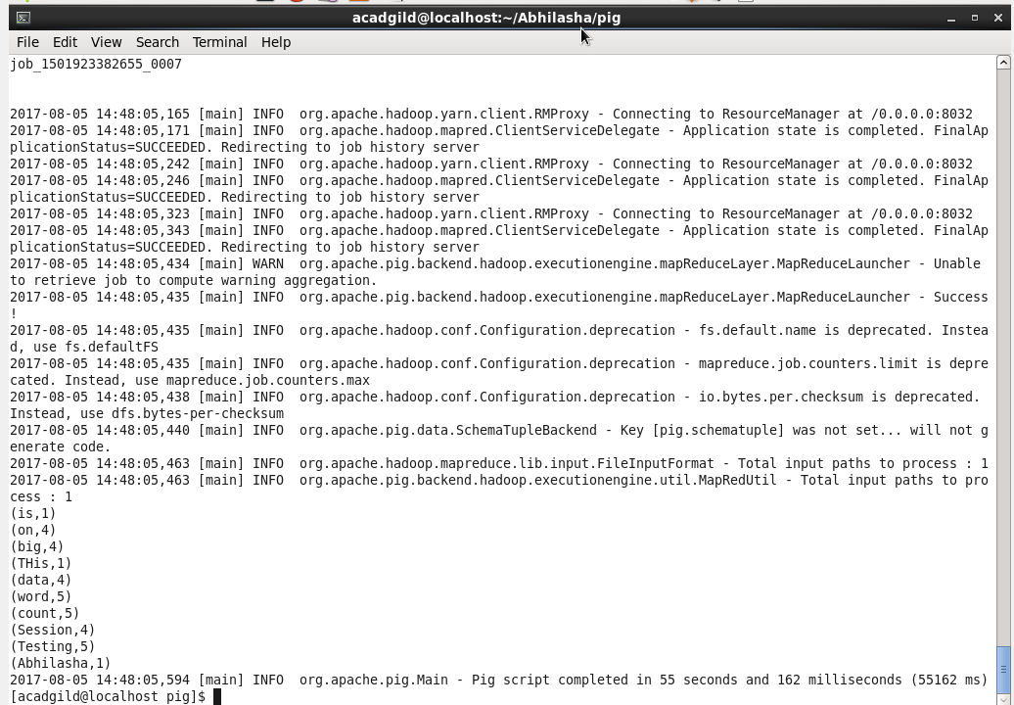
As we ran script in mapreduce mode, the job history server mentions the success of the job as follows:
